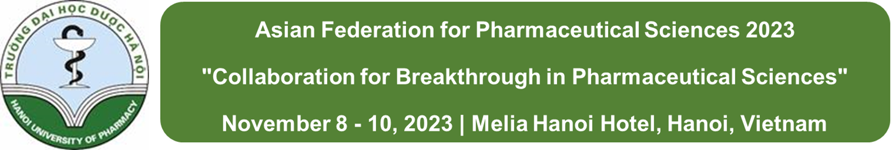
Abstract Form
❏ Presentation title: PEGylated-paclitaxel and dihydroartemisinin nanoparticles for simultaneously delivering paclitaxel and dihydroartemisinin to colorectal cancer
Thien Giap Le ^{1,a}, Cao Dai Phung^{2,a} , Van Hai Nguyen³, Thi Trang Vu¹, Huong Quynh Nguyen¹, Jong Oh Kim², Chul Soon Yong^{2**,} and Chien Ngoc Nguyen^{1,3*}
¹National Institute of Pharmaceutical Technology, Hanoi University of Pharmacy, 15 Le Thanh Tong, Hanoi, Vietnam
²College of Pharmacy, Yeungnam University, 214-1, Dae-Dong, Gyeongsan 712-749, South Korea
³Department of Pharmaceutical Industry, Hanoi University of Pharmacy, 15 Le Thanh Tong, Hanoi, Vietnam
*Corresponding author: Chien Ngoc Nguyen, Assoc. Prof. Dr.
**Co-corresponding author: Chul Soon Yong, Prof. Dr.
Presenter | Chien Ngoc Nguyen | Email: chiennn@hup.edu.vn
❏ Abstract (up to 250 words) ※Please refer to below
Purpose Development of a nanoplatform constructed by the PEG-dual drug conjugation for co-delivery of paclitaxel (PTX) and Dihydroartemisinin (DHA) to the tumor.
Methods PEG was conjugated with PTX and DHA to form PTX-PEG-DHA complex as a nanocarrier. The PTX and DHA were co-encapsulated in PTX-PEG-DHA nanoparticles (PD@PPD NPs) by the emulsion evaporation method. The physicochemical properties of PD@PPD Nps were characterized, including size, zeta potential, and morphology. The drug loading capacity and entrapment efficiency, in vitro drug release at different pH conditions were also evaluated. For in vitro assessment, the effects of the NPs on HT-29 colorectal cancer cells, including intracellular uptake, cytotoxicity, and Bcl-2 protein expression were assessed. The in vivo distribution of the NPs was investigated by labelling the NPs with Cyanine 5.5 fluorophore. Finally, the antitumor efficacy of the NPs was evaluated in HT-29 tumor-bearing mice.
Results The nanoparticles were formed at small size (~114 nm) and narrow distribution. The combination of PTX and DHA in the DHA-PEG-PTX nanosystems (PD@PPD) showed remarkably increased apoptosis in colorectal adenocarcinoma HT-29 cells, as compared to free drug treatment. More importantly, the PD@PPD nanoparticles exhibited significantly higher accumulation in the tumor site owing to the enhanced permeability and retention (EPR) effect, effectively restrained the tumor growth in vivo at low-dose of PTX while reducing the systemic toxicity.
Conclusions The combination of PTX and DHA in a PEG-conjugated dual-drug co-delivery system can minimize the severe side effect associated with the high-dose of PTX while enhancing the antitumor efficacy.
KEYWORDS (up to 5 words): Dihydroartemisinin, paclitaxel, PEGylated, nanoparticle, combination chemotherapy.
❏ Graphical abstract (optional) ※Please refer to below
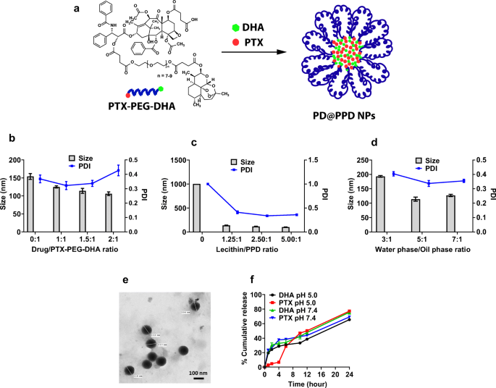
※ Please fill out this form in English and upload at AFPS’s homepage: http://www.2021afps.org/

